

* Boys are more attracted to games with violence of some kind whereas girls are more attracted to nurturing or methodical games
* 59% gamers are male (as of ESA study 2016)
* Of all ‘super genres’, Action and Shooters were the top two sold in 2014 and 2015

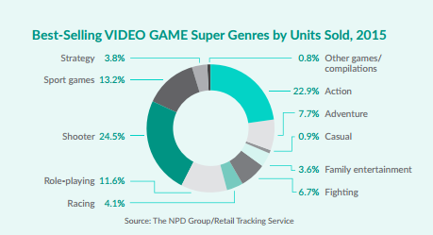

* Looking at a variety of games with either a Teen rating from the ESRB or PEGI rating of 12+, technology and space seem to be common themes
* OLO is 2 player adversarial physics game that features gameplay mechanics similar to those of billiards
* Pocket Tanks features a selection of different weapons that have different effects on both the players and their surrounding environment

<https://www.reddit.com/r/truegaming/comments/2xa9a5/gender_and_computer_game_players_who_seems_to/>

<http://www.pewinternet.org/2015/08/06/chapter-3-video-games-are-key-elements-in-friendships-for-many-boys/>

<http://www.theesa.com/wp-content/uploads/2015/04/ESA-Essential-Facts-2015.pdf>

<http://essentialfacts.theesa.com/Essential-Facts-2016.pdf>

<https://www.thestudentroom.co.uk/showthread.php?t=1507090>

<https://www.esrb.org/ratings/ratings_guide.aspx>